LionQ

Jeanna Maye Benitez

CST-451 Capstone Project Proposal

Grand Canyon University

Professor Mark Reha

Revision: 2.0

April 24, 2022

**ABSTRACT**

This project is a social media website where users can create posts, comment on other user’s posts and give feedback, private message other users, and personalize their profile to their liking. The user’s posts will be stored in a database that will be saved, so that their posts will show up when another user clicks on their profile, like a timeline. The users can search posts by the title of the post and search users as well.

The website allows users to connect with other people around the world. It allows for them to create a community and meet new people with common interests. Users can message each other and the messages will save to a database, so that users can search for previous messages. The website will then be uploaded to the cloud, which will then allow users to access the site through a global link.

| History and Signoff Sheet |
| --- |

**Change Record**

| **Date** | **Author** | **Revision Notes** |
| --- | --- | --- |
| 9/26/2021 | Jeanna Benitez | Initial draft for review/discussion |
| 04/05/2022 | Jeanna Benitez | Updated Abstract, Project Objectives, Project Scope & Work Breakdown Structure |
|  |  |  |

| **Overall Instructor Feedback/Comments** |
| --- |

| **Overall Instructor Feedback/Comments** |
| --- |

**Integrated Instructor Feedback into Project Documentation**

* Yes
* No

**Project Approval**

* Professor Mark Reha

**TABLE OF CONTENTS**

**Project Overview and Project Objectives 4**

**Project Scope 5**

**Project Success Measures 6**

**Project High-Level Solution 7**

**Project Controls 8**

**Project Cost and Schedule 10**

**Appendix A – References 11**

**Appendix B – Copyright Compliance 12**

**Project Overview and Project Objectives**

**State the Problem and Background**

To incorporate modern trends into this product and for it to relate to the current generation. There are a lot of websites out there that the current generation does not use a lot because it seems outdated. Creating this product will introduce a site where people can post what they want (with restrictions), comment on posts, private message other users, and more.

**Project Objectives**

* Total users per week/month
* Users able to create posts & look at others’ posts
* Multiple users able to access product through cloud
* Creating a chat client for users

**Challenges**

* Uploading product to the cloud
* Creating the product within a short time period while also working on other projects due to other classes
* Being able to use front-end JavaScript properly in the product

**Benefits and Opportunities**

Users from all over the world will be able to interact with each other and even give feedback on other work. They will be able to converse with others, build communities, and express themselves in their profile and posts however they like.

**Project Scope**

| In-Scope | Out-of-Scope |
| --- | --- |
| * Register User * User Login * View Profile * Search Users * Create Post * Delete Post * Update Post * Search Post * List Posts via User Page * Message Users | * Show Personal time for user * “Help” Feature via Email * Share profile to others * Unique Greeting from home page * Customize Profile via color scheme * Comment on Post * Post videos/pictures |

| **Work Breakdown Structure** | | | | | | | | | | |
| --- | --- | --- | --- | --- | --- | --- | --- | --- | --- | --- |
| **ID** | **Task** | **Dependencies** | **Status** | **Effort Hours** | **Cost** | **Start Date** | **Completion** | **Estimate to Completion** | **Actual Completion** | **Resource** |
| 1 | Project Proposal Document | N/A | Complete | 8 | N/A | 9/19 | 9/26 | Complete | Complete | Project Proposal Template |
| 2 | Project Requirements  Document | Project Proposal | Complete | 8 | N/A | 9/27 | 10/24 | Complete | Complete | Project Requirements Template |
| 3 | Final Plan Document | Project Requirements | Complete | 8 | N/A | 10/25 | 11/21 | Complete | Complete | Final Architectural Plan Template |
| 4 | Implementation Plan, Requirements Mapping, Module Test Cases,  Source Code Listing, Application Demonstration | Final Plan | Complete | 8 | N/A | 11/22 | 12/19 | Complete | Complete | Capstone Handbook,  Test Cases Template |
| 5 | Learning JavaScript | N/A | Complete | 20 | N/A | 02/01 | 04/03 | Complete | Complete | SoloLearn Tutorials, Classes, Youtube Tutorials |
| 6 | Website Prototype (User Login/Register, Posts, Comments) | N/A | Complete | 12 | N/A | 12/01 | 01/23 | Complete | Complete | Eclipse Spring MVC |
| 7 | User Creates Posts | Website Prototype | Complete | 16 | N/A | 01/24 | 02/27 | Complete | Complete | Eclipse Spring MVC |
| 8 | Search Posts | Website Prototype | Complete | 2 | N/A | 01/24 | 1/30 | Complete | Complete | Eclipse Spring MVC |
| 9 | Update/Delete Posts | Website Prototype | Not Yet Started | 11 | N/A | 01/24 | 03/06 | Complete | Complete | Eclipse Spring MVC |
| 10 | View Profile (Post Timeline & Edit Profile) | Website Prototype | Not Yet Started | 10 | N/A | 02/06 | 02/13 | Complete | Complete | Eclipse Spring MVC |
| 11 | Message Users | Website Prototype | Not Yet Started | 18 | N/A | 02/06 | 04/03 | Complete | Complete | Spring MVC, STOMP Client |
| 12 | Upload to Cloud | Entire Website Complete | Not Yet Started | 1 | N/A | 04/03 | 04/04 | Complete | Complete | Eclipse Spring MVC  Microsoft Azure |

**Project Success Measures**

The quality of the product and how well it does with the community, when the product gets completed and how well it is built to completion, and uploading the product to the cloud and how well users are able to access the website

| Project Completion Criteria |
| --- |
| 1 - Project completed on time with most functionalities |
| 2 - Project implements functional requirements |
| 3 - Project uploaded to the cloud |

| Assumptions and Constraints | | | | | |
| --- | --- | --- | --- | --- | --- |
| ID | Description | Comments | Type | Status | Date Entered |
| 1 | Cloud is able to withstand multiple users accessing the website | Upgrade Storage or Possibly move to another cloud service if it cannot be solved | Constraint | TBD | 9/23 |
| 2 | MySQL Database able to withstand multiple data entries at once | Test data entries, and the accuracy of data being input into the database | Assumption | TBD | 9/23 |

**Project High-Level Solution**

**Introduction**

The product is a social media website where users will be able to create a profile, create posts, reply to posts, and message other users. People are able to express themselves in their profiles and their posts, and connect with others who may have similar interests as them. This will bring people close together from other countries, cultures, and cities. Through this website, people are able to express themselves in a way they may not be able to in the real world. There will be restrictions in place within the website that will prohibit things like online bullying, harassment, etc. Every data input the user enters like posts, or creating their profile, will be saved into a database and will output the data onto the web page for the user to see. After every aspect of the website is developed completely, it will get uploaded to a cloud for users to be able to access globally. Assuming that the website does not crash due to the amount of users inputting data (creating profiles, posts, etc.), the website will be up and running for all users to access.

**Solution**

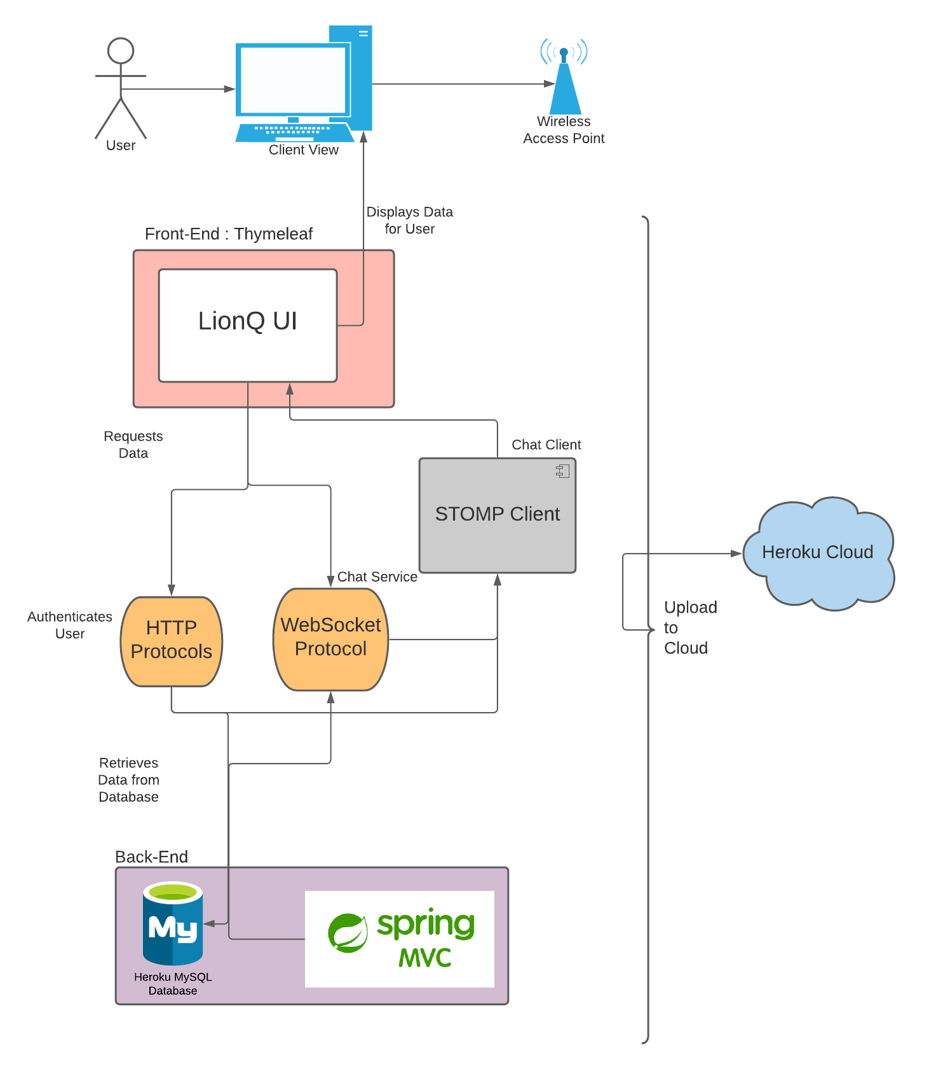

The LionQ is a social media website that the client (or user) will be able to access through the Heroku cloud, where the website will be uploaded to, once the website is fully developed for the public. The user will be able to create an account, so that they can access the other features the website provides, like commenting on others’ posts or messaging other users. That is a portion of security and authentication the website will have through HTTP protocols created in Spring. The website will be created by using the Spring MVC framework and Thymeleaf for the front-end design of the project. Users will be able to privately message one another through HTTP and WebSocket protocols, along with a STOMP client to create the chat service. They will be able to request data from the MySQL database (where all data input is stored), like searching for posts or other users. The data will then be called from the database and can be displayed for the user to see in the client view. This framework allows for efficient web development and will allow for easy implementation for users to communicate to one another within the website. All messages between the users will be stored in the database and will be requested when the user wants to load their private messages page.

**Project Controls**

| Risk Management | | | | |
| --- | --- | --- | --- | --- |
|  | **Risk Probability** | **Risk Impact** |  |  |
| **Event Risk** | **(high, medium, low)** | **Risk Mitigation** | **Contingency Plan** |
| What is the risk? | What is the probability? | What is the impact if the risk occurs? | What can be done to minimize the risk? | What can be done to minimize the impact of the risk? |
| JavaScript | medium | Web page refreshes each time user exits | Learning more about front-end JavaScript | Using Razor in the .NET MVC and learning more about Spring Boot and how it works |
| Web Page Security | low | Someone could change data or access another person’s profile | Developing page by page security | Creating security as each page is made |
| WebSocket Protocol & STOMP Client | high | There will not be a messages feature in the project | Learning the process and implementation of WebSocket and STOMP | Replace the feature with a simple post reply and have the messages feature be a future update for the project |

| Issues Log | | | | | | | | |
| --- | --- | --- | --- | --- | --- | --- | --- | --- |
| **ID** | **Description** | **Project Impact** | **Action Plan/Resolution** | **Owner** | **Importance** | **Date Entered** | **Date to Review** | **Date Resolved** |
| 1 | What is the issue? | How will this impact scope, schedule & cost? | How do you intend to deal with this issue? | Who manages this issue? |  |  |  |  |
| 2 |  |  |  |  |  |  |  |  |
| 3 |  |  |  |  |  |  |  |  |

| Change Control Log | | | | | | | | | |
| --- | --- | --- | --- | --- | --- | --- | --- | --- | --- |
| **ID** | **Change Description** | **Priority** | **Originator** | **Date Entered** | **Date Assigned** | **Evaluator** | **Status** | **Date of Decision** | **Included in Rev. #** |
| 1 |  |  |  |  |  |  |  |  |  |
| 2 |  |  |  |  |  |  |  |  |  |

| Roles and Responsibilities | | | |
| --- | --- | --- | --- |
| Name | Team | Project Role | Responsibility |
| Jeanna Maye Benitez | N/A | Developer | Develop the product that has data input/output, and an easy-to-read website |
|  |  |  |  |

**Project Cost and Schedule**

This project will require some cost for the application to be deployed in Azure Spring Cloud service.

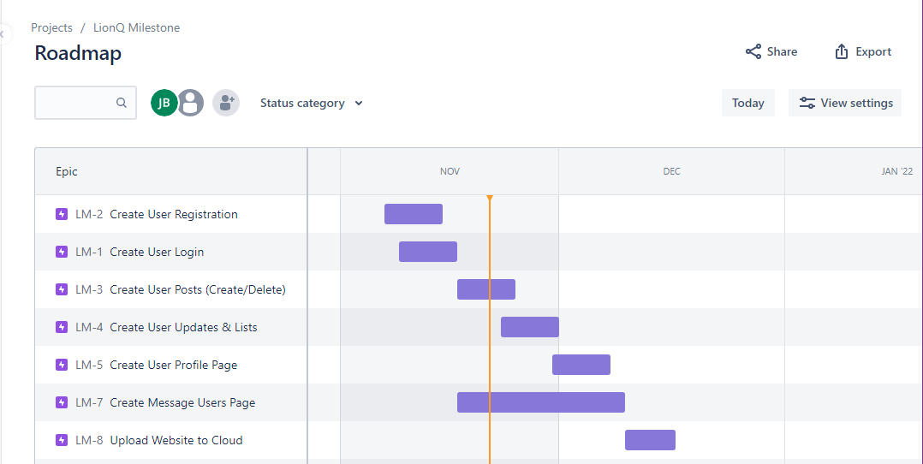

**Appendix A – References**

*Saleh, A. (2021, September 12). Building persistable one-to-one chat application using spring boot and websockets. Medium. Retrieved September 27, 2021, from https://medium.com/javarevisited/building-persistable-one-to-one-chat-application-using-spring-boot-and-websockets-303ba5d30bb0.*

**Appendix B – Copyright Compliance**

This product will use SockJs and Stomp.js libraries to create a chat client for the product.

